Wightlink-Wight Mountain CRT
Presents

The Wightlink-Island Renewables Military Road 35km Time Trial

Promoted for and on behalf of Cycling Time Trials under their Rules and Regulations

Course: PO56 Event Secretary: Julie Cooper
Date: Sunday, 10th September 2023 45b St John’s Road
Start Time: 09.30 – First rider off at 09.31 Sandown
Isle of Wight
Timekeepers: Start: Russ Thomson / Russell Page PO36 8HS
Finish: Jerry Cooper / Dizz Dyer Email: wightlinkrt@gmail.com
Tel No: 07743 870 146

HQ Sign On : West Wight Sports and Community Centre
Moa Place
Freshwater
PO40 9XH

There is a Pay & Display car park at the HQ or ample parking on the surrounding roads. The HQ also has a café and changing facilities (including showers). Directions for Sign On will be at the main entrance – weather permitting this will be outside on the field adjacent to the main building. There is also a small chalk car park at the finish but no parking along the road.

Just a few reminders: Sign in will commence from 08.45 - First rider off at 09.31. Please ensure that you sign in, collect your number and arrive at the start line in good time to avoid disappointment - but NO MORE THAN 5 MINUTES BEFORE YOUR START TIME AND PLEASE AVOID STANDING IN GROUPS ON THE ROAD.
- All competitors must wear a helmet and bikes must have a red rear light AND a front light (new CTT regulations for 2022) - these will be checked at the start.
- Under no circumstances should riders do a U-turn in the road - After passing the finish line, proceed directly to the HQ to sign out and hand in number.
- There will be a 'holder-upper' for riders at the start line for this event. Riders must keep both hands on the bars at all times and must not ride with their elbows resting on the tops of the bars on bikes without tri-bars (new CTT regulations for 2023).
- Riders should watch their speed when cornering and MUST NOT CROSS WHITE LINES - this could lead to disqualification.
- Overtaking - If you catch another rider on the course, please ensure that you follow the rules of the road and check to ensure it is clear behind before making the manoeuvre.
- Riders must make their own judgement when exiting junctions - it is not the role of marshals on the course to stop oncoming vehicles.
- Riders should not warm up on the course once the racing has started at 09.31.
Route from HQ to the Start: Turn right out of the Centre and follow School Green Road to the mini roundabout. Straight on at the roundabout and start line is on the left just past the Tesco store.

PO56 Course Description:

Out and back course with 4 climbs at 1.4km, 4km, 18km, 32.5 and a roundabout turn at 19km.

START: On Afton Road A3055 approximately 100m south of the Honor & Jeffrey Garden Centre adjacent to the public footpath. Continue south along Afton Road A3055 to the junction with Military Road A3055 at 1.4km. Turn left and ascend the first climb at Freshwater Bay. Continue south-east along Military Road A3055 to Chale and continue to the roundabout halfway up Blythe Shute. Turn at roundabout and return to the Military Road A3055. Continue north-west along the Military Road A3055 to finish at the chalk car park halfway up the last climb.

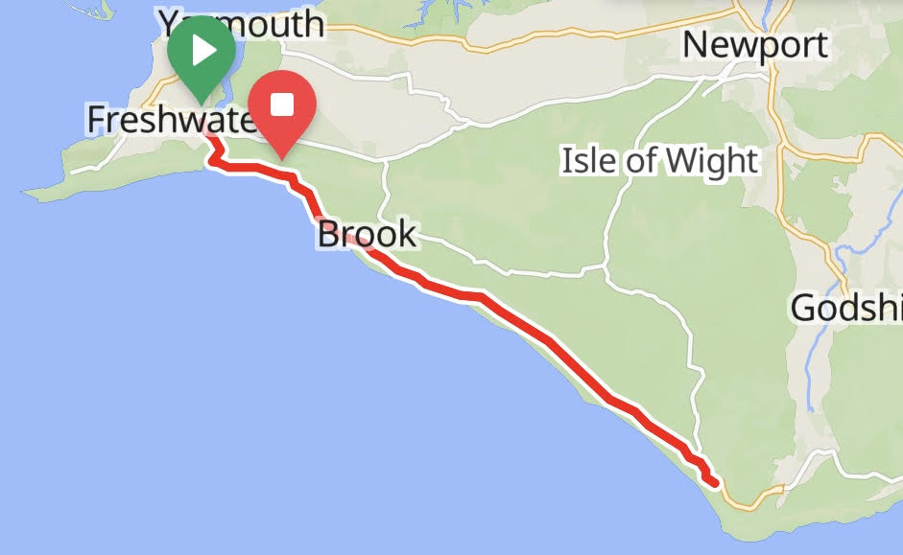

Safe Route from the Finish to the HQ

Riders will be instructed when signing on to continue along the Military Road A3055 and then straight ahead onto Gate Lane before turning right onto Victoria Road and then follow the signs back to the HQ at West Wight Sports and Community Centre. Riders should not stop or perform a U-turn in the road after crossing the finish line.

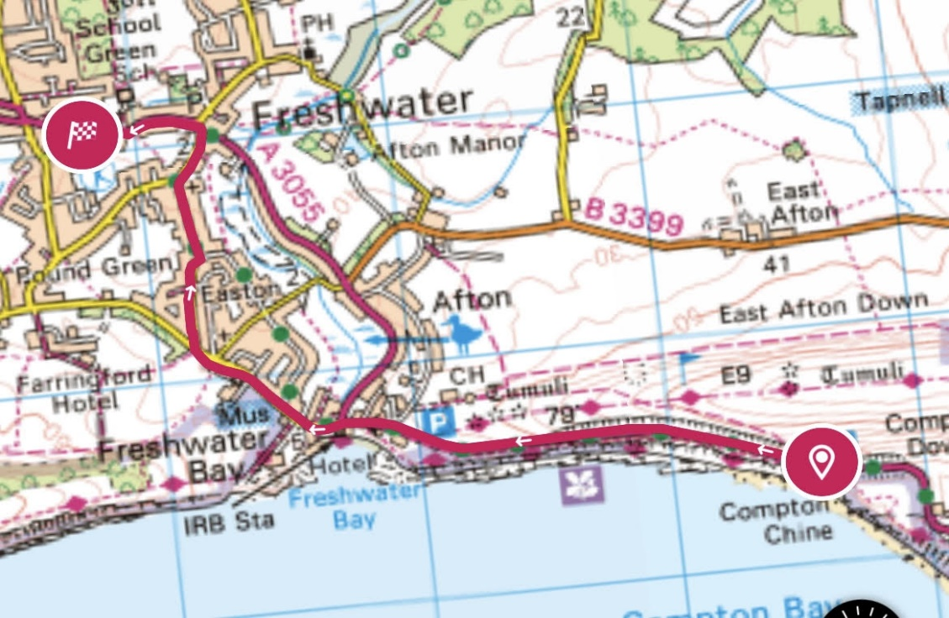
Prizes and Trophies:

There will be prizes and trophies courtesy of the event sponsors Wightlink, Island Renewables Ltd and Kreative Studios for category winners and podiums as follows:

TT Bikes
Men / Junior Boys

Road Bikes
Men / Women / Junior Boys / Junior Girls

Overall Vet 40+

Overall Vet 50+

Overall Vet 60+

There will also be a free rider raffle for all competitors to win a £50 Wightlink voucher (x 2)

Wightlink-Wight Mountain CRT are proud supporters of Mountbatten Hospice Isle of Wight
Our Annual Grand Draw will be held after the presentation and all proceeds will to go to this worthwhile charity.

